**HR & Manager Round Questions**

**Ques - Tell me about yourself?**

My name is Rahul Patidar, I am from Indore Madhya Pradesh India. I completed my Graduation in 2014 and after that I started my career in IT industry. I am having total 8 yr. of experience and totally in QA and fully comfortable in manual as well as automation testing.

Currently I’m working in Nuance India, where my roles and responsibilities are:

* Go through the requirement documents for assigned tickets.
* Prepare the test case and check the automation feasibility.
* Execute test case and write automation test if possible.
* Responsible for maintenance of automation framework.
* Participate in all scrum ceremonies.
* Participate in all tech talks!
* Participate in release process.
* Regression end E2E test execution.
* Share the reports with the management.

**Ques - Tell me about your project? What challenges you faced? how you handled?**

Currently I’m working in Mix platform which is enterprise application and used to integrate with different application including banking, financial, insurance and other automotive machines and provide different type of services including TTS, ASR, NLU, DLG and companies can design flow as per their need.

**Challenges:**

* In Agile world, sometimes frequent changes of the requirement are bit difficult to manage.
* Sometimes we have to do quick releases and for that our regression and E2E suite be stable.
* We are using microservice architecture and in our E2E suite we are using multiple services and if any of the services is down then test case can create problem, so need to take care of this validation as well.

Follow **ATLC** for writing automation test

**ATLC (automation test life cycle)**

**1.Automation feasibility analysis**-  Which test case can be automated and how we can automate them. Also will check which test cases cannot be automate.

**2.Test plan and Design**- Fetch all the manual test case from test management tool that which TC has to automate. Which framework to use and what will be advantage and disadvantage of the framework which we will use.

**3.enviorment setup**-  What should be the configuration in terms of hardware and software.

**4.test script creation-**

* Start creating test script based on your requirement.
* Create some common method or function that you can reuse throughout your script.
* Make your script easy, reusable, well-structured and well documented so if third person check your script then he/she can understand your scripts easily.
* Use better reporting so in case of failing you can trace your code.
* Finally review your script and your script should be ready before consumption.

**5.Test case execution**

* Your script should cover all the functional requirement as per test case.
* Your script should be stable so it should run in multiple environment and multiple browsers (depends on your requirement)
* You can do batch execution also if possible so it will save time and effort.
* In case of failure your script should take screen shots.
* If test case is failing due to functionality, you have to raise a bug/defect.

**6. Analysis of result**

* Analyze the output and calculate how much time it takes to complete the test case.
* You should have good report generation like Extent/Allure report etc.

**Challenges in automation testing:**

* Synchronization is big problem is automation but for that we have to use Implicit and explicit wait provided by selenium but sometimes you will not find proper element so that time you need to write some logic- like refresh or run a loop 2-3 times so maybe you will get.
* Finding locator is sometimes difficult on dynamic pages, so try to use open-source plugin like **SelectorHub**.
* When you are designing any framework make sure to use standard design pattern like **POM** and take care of
  + Base class
  + All page classes.
  + All test classes.
  + All the reusable logics (screenshot, reporting, logging)
  + Handling developer mode extension or authentication problem.
  + Data storage (excel, properties file, database)
* Maintenance of framework is bit difficult.
* Dealing and handling with Exception is also tough challenge.
* When you are integrating selenium with TestNG or Maven need to take care of all the libraries and dependencies.
* Sometimes test work properly on 1 env but not on other.
* Sometimes test work properly on local machine but not on remote.
* Sometimes test work properly on 1 browser but not all other.

**Ques - What is Framework, which framework you used in your project and why, explain architecture and modules/ components of framework?**

* Framework means set of rules, guidelines, concepts, practices that we need to follow is our automation script. And with the help of framework we can design clean, robust and strong test scripts.
* There is no defined structure for framework, each company is using their own way to design framework.
* And for the designing of framework we used Selenium webdriver, TestNG with POM design concept so that we can easily reuse our script.
* We are using hybrid framework.

First I will explain the **architecture** of framework.

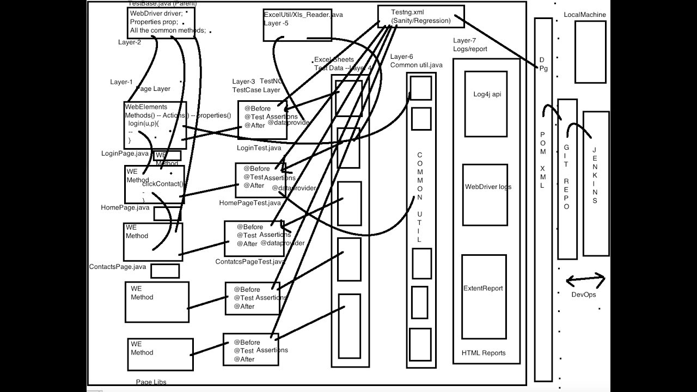

Folder Structure-

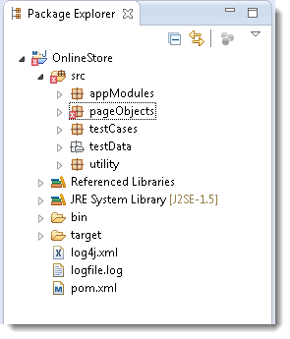

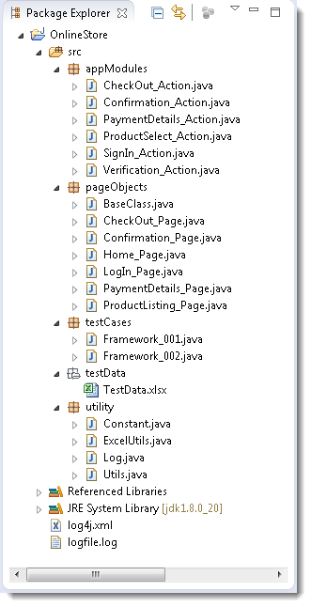

Components/Modules-

* 1. Test Case Standardization (all the test case should follow same approach)
  2. Logging Standardization (common way)
  3. Test data & Configuration Utility (Excel, config file)
  4. Helper/Utility Library (common functionality- Screenshot, login etc)
  5. Test execution engine (POM, TestNG etc)
  6. Reporting Utility.

**Ques - Why do you want to work here?**

For personal and financial growth (also research about company).

**Ques - What are your strength?**

I can easily adjust in new situation, new environment with new people I can say am adaptive by nature.

I do my job with dedication and complete our work in given deadline.

Flexibility- can work in team and individually too.

**Ques - Weakness?**

Sometimes feel bored doing same thing again and again.

Bit lazy about which I am not interested like submit a timesheet, give feedback etc.

**Ques - Why should I hire you?**

Company is looking for the automation profile and I feel I’m the good candidate for this job, and I am sincere with my work and would never let you down in anyway.

**Ques - Tell me about this company?**

**Ques - Why you are looking for a job change?**

personal and financial growth. And this is the good company where I can learn and gain more.

**Ques - What are your salary requirement?**

**Ques - What are your career goal?**

**Ques - Do you have any question to ask me?**  
Thanks for asking this question, tell me something about product which I’m going to work if selected and what will be my role and responsibilities.

**Ques - What you mention in Status mail?**

Whatever work I completed and highlight risks if any.

Defects if found and the reason

What I’m going to do next

**Ques - Project management tool JIRA explain?**

* It is used for **bug tracking.**
* **Project management.**
* **Release planning.**
* **Work coordination**
* **Manage Sprint, Epic, Stories, Backlogs, Defects.**
* **Create different dashboards for project.**

**Assessing the Performance of Your QA and Testing Team?**

**I often hear people talking about Performance Metrics and Key Performance Indicators, but how to define quality engineering productivity exactly? What is it and how to measure? And what are some best practices to increase?**

**How can I evaluate the performance, productivity, and improvement of a Quality Engineer?**

**Is it depending on time spend at the workplace, number of bugs found, certifications.etc. or something like that?**

**QA and testing teams are increasingly faced with strict deadlines and pressure to deliver on releases faster.**

* Measure the number of bugs found per release.
* Reviewed Requirements. Number of automated test cases created and executed and Covered Requirements
* Ratio of bugs being reported to bugs being fixed.
* Number of bugs found in staging vs. production.
* Severity of bugs found in production.
* Number of bugs sent back for clarification.
* Number of bugs over time (not just for one build, but overall ñ shows a broader understanding of mitigating issues early on)
* Time to execute a test cycle.
* Turnaround time for fixing issues (quickness is necessary to keep the project moving forward)
* Number of regression test gaps.

managers walk around in the developer pit and talk to people, listen to people, and get a sense of how the team is functioning on a regular basis. This will tell a manager more about his people's performance.

**how to decide which test cases to automate using selenium?**

* Repetitive tests that run for multiple builds.
* Tests that require multiple data sets.
* Frequently used functionality that introduces high risk conditions.
* Tests that are impossible to perform manually.
* Tests that run on several different hardware or software platforms and configurations.
* Tests that take a lot of effort and time when manual testing.
* Good to execute the cross-platform test cases (like different OS, browsers etc.)
* Test case executed with different set of data.
* Test case executed with different browser.
* Test case executed with different environment.
* Test case executed with complex business logic.
* Test case Involves large amount of data.

**how to review the automation code**

* Should follow test case standardization.
* Follow logging/validation standard.
* Assertion should be there in code.
* Always write dynamic locator.
* All the test cases should be independent to each other.
* All the pages should be independent to each other.
* Don't use hardcoded values.
* Use good level of abstraction.
* Always use dynamic waits.
* Try to run test case multiple times, so you can check the stability.
* Dry run to check functionality.
* Code optimization
* Code duplication
* Use oops concepts.
* Do peer review.
* Team review

**What to do when defect is found in production but not during the QA phase?**

* Check for impact on the system. And if is of high severity and high priority, call for a hot fix.
* Do a retrospective meeting and find the root cause for the defect and make sure that we have test scenarios and test cases ready for regression.
* Perform a quick regression on QA Environment for the hot fix and make sure that build is stable, and no new defects introduced because of the defect.
* QA gives approval for moving build to PROD Environment and performs regression testing and signoff for the release.

**What if u miss release deadline?**

**Situation where u agree/disagree with your lead/manager/senior member?**

**What will you do if someone is asking for help in your team?**

**Suppose u did some POC and it does not work as planned, how u will handle it?**

**If u selected, how u will start or first thing u will do?**

Take knowledge of domain/product.

Will go through the Framework, best practices followed.

**Describe when u face unexpected challenge?**

Will talk to my manager/lead, will explain situation, and definitely will get some suggestion and try to handle the situation and learn things.

**Do u prefer working in team env or individual env?**

Personally, I’ll love to work with the team and that is how we can build good relation, but if requirement is do work alone than I’m ready to work not an issue.

**Do u prefer weekend/late night work?**

Whenever required will do it but unnecessary will not ask my team to come/work on weekend.

**Any difficult working with manager/team/company?**

Sometimes we can disagree with the team member/manager, So provide your view with proper reason, try to explain the situation but I always had good relation with my team and leads.

**how to handle if some member of your team is not working?**

Talk to that person, understand the situation, and try to provide solution and still if he/she is not understating talk to lead/manager politely and ask him/her to help or talk to that person.

**What is your daily activity?**

Will check my email, is there any imp email will reply to those, then will check my board and work, will join all required meetings and discussion.

**As a QA, when u most proud of yourself?**

Especially when get good feedback/appreciation from PO/clint, that really motivates me.

**How to priorities your work?**

It is always based on project, if we have to do some critical task 1st, then definitely start with it, if some security trainings required on priority will do that, it’s all about project/product and then rest of the work.

**How do u know if shared KT session in worked perfectly?**

Will try to give some basic task /assignment and ask to do it or may will take reverse KT in positive way and help if required.

**How u handle difficult customer issue?**

1st will try to investigate, will check why we missed or is there any env issue, is test covered or not if not will try to add in our regression?

**What excite you to coming to work?**

Meet to my team member, discussion about some topic, share knowledge to each other.

**How to showcase your knowledge in interview?**

Share screen and if possible, show repo which you created, how u r executing test via pipeline and all.